Ware-OPs

**Optimizing warehouse space with Arduino powered   robotics and drive in racks.**

*by*

**Aadith M Mathew**

**(23MIC7005)**

**Aayushi Maji**

**(23BEC7031)**

**Anaswara Jayakumar**

**(23BCE8438)**

**Hari Krishnan B**

**(23BME7041)**

**Jinu Joji**

**(23BCE8495)**

**Mekha Manosh**

**(23BCE8164)**

*Under the guidance of*

**Prof  Dr. Anurag De**

**VIT-AP University, Amaravati, Andhra Pradesh - 522237**

**ABSTRACT**

Ware-Ops is a pick-and-place robot powered by Arduino UNO for warehouse management and administration. It is used to solve the most prevalent issues in warehouse, including sorting, space use, and real-time inventory counts. Ware-Ops guarantees accurate and effective item handling with the use of an ESP32-CAM module for object detection, size-based sorting, and QR code scanning for navigation.  
The system uses a variety of sensors, including infrared and ultrasonic sensors, to detect obstacles and for navigation, thus allowing it to change direction and move smoothly through drive-in racks. In addition, a robust pick-and-place mechanism, with a forklift attachment, enables Ware-Ops to move items to locations based on their size and priority  
A central server system achieves centralized control and data processing, managing all the inventory counts, while the ESP32-CAM transmits images for processing into the system. This even allows for remote operation and control of the device. Integrated with embedded systems and the Internet of Things, fast and accurate item retrieval and placement are achieved with energy-conserving and waste-saving practices, making Ware-Ops the innovative solution for modern warehouses

**TABLE OF CONTENTS**

|  |  |  |
| --- | --- | --- |
| **CHAPTER NO.** | **TITLE** | **PAGE NO.** |
|  | **ABSTRACT** |  |
|  | **LIST OF FIGURES** |  |
|  | **LIST OF TABLES** |  |
|  |  |  |
| **1** | **INTRODUCTION** |  |
| **2** | **PROCEDURE** |  |
| **3** | **RESULTS** |  |
| **4** | **CONCLUSION** |  |
| **5** | **REFERENCES** |  |
| **6** | **LIST OF CODES** |  |
| **7** | **PRIOR ART** |  |

**LIST OF FIGURES**

|  |  |
| --- | --- |
| **Sl.NO.** | **TITLE** |
| 1 | **CIRCUIT DIAGRAM** |
| 2 | **COMPREHENSIVE OVERVIEW OF THE HARDWARE ARCHITECTURE** |
| 3 | **BLOCK OF DIFFERENT SIZE** |
| 4 | **FLOW OF SIMULATION OF ROBOT** |
| 5 | **FLOW OF SIMULATION OF THE INTERSECTION MODULE** |
| 6 | **SNAPSHOTS OF PROTOTYPE** |

1. Circuit Diagrams

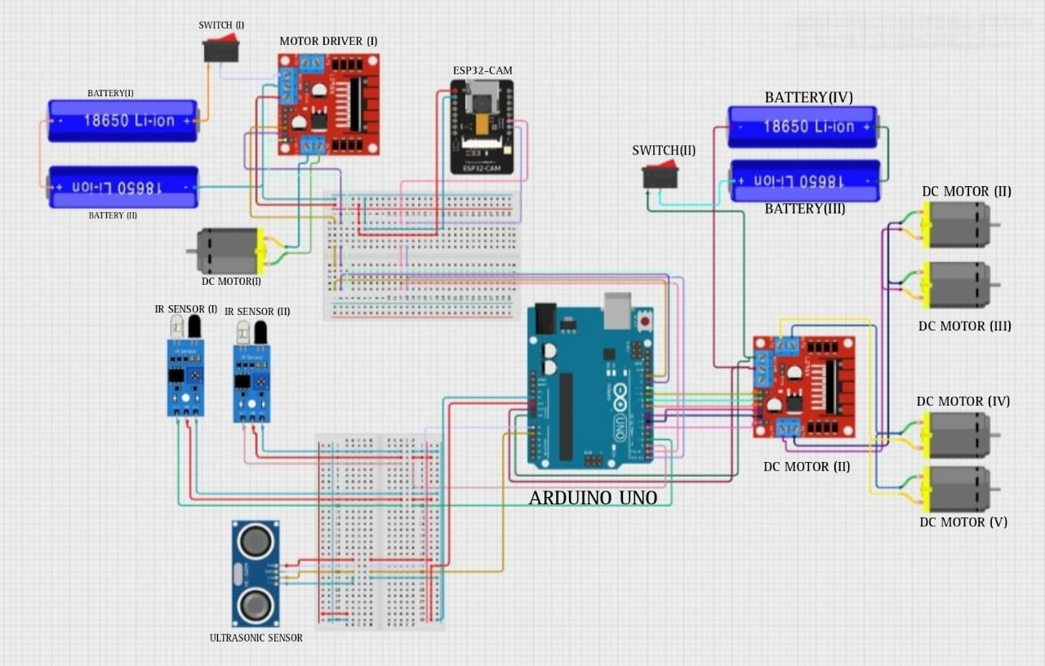

1. **Comprehensive Overview of the Hardware Architecture**

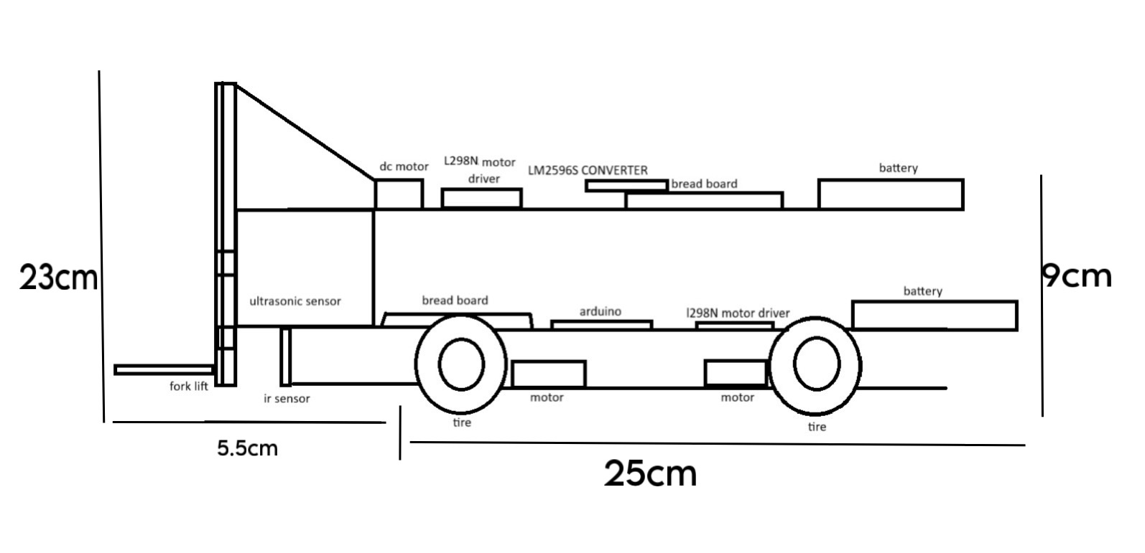

side view

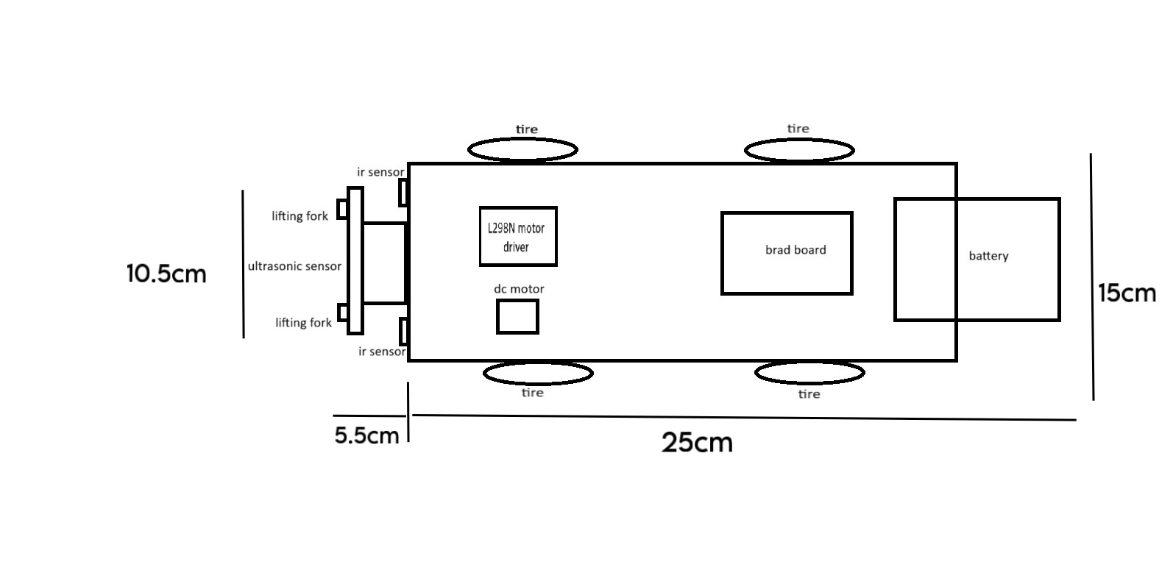top view

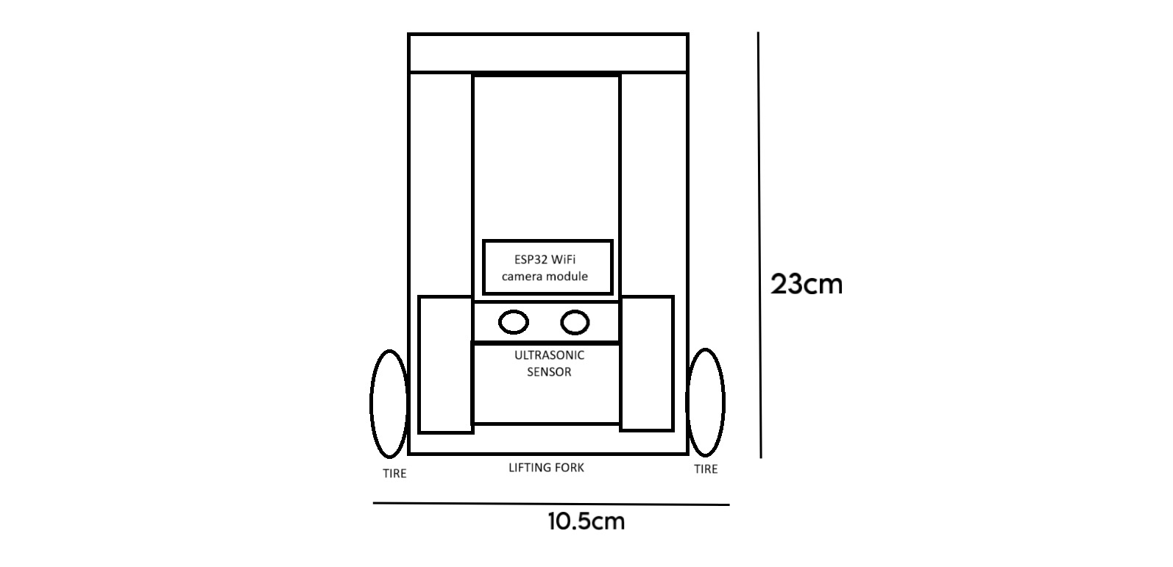

front view

1. **Block of different size: small, medium, big from left to right**

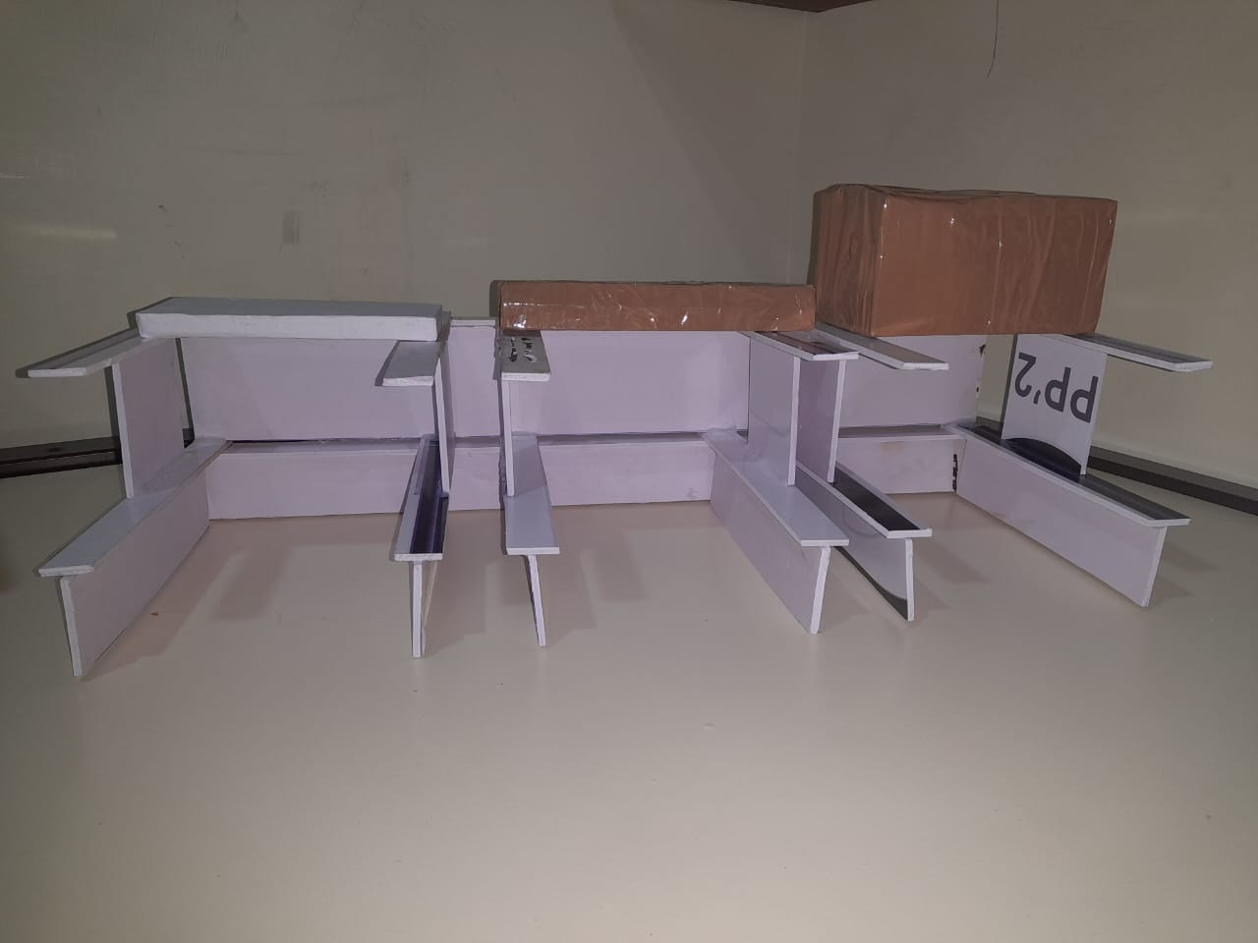

1. **Flow of simulation of the program flow**

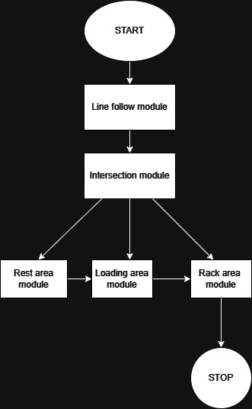

**5.Flow of simulation of the line flow module**

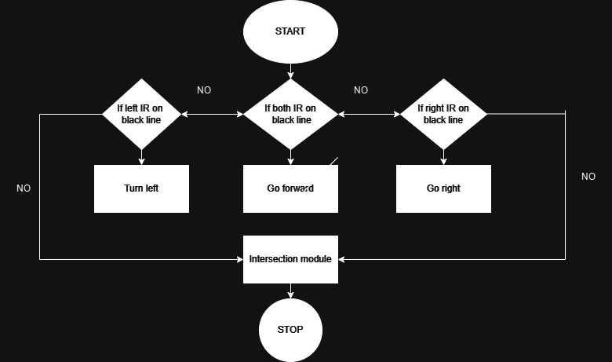

**6.Flow of simulation of the Intersection module**

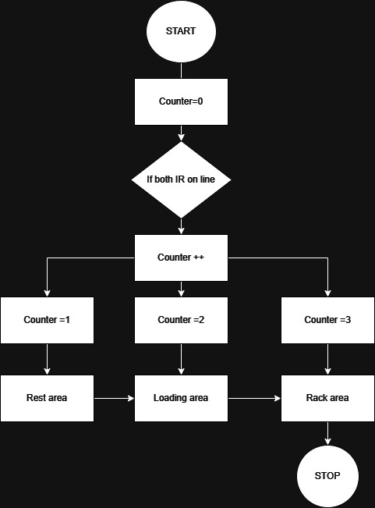

1. **Snapshots of the prototype**

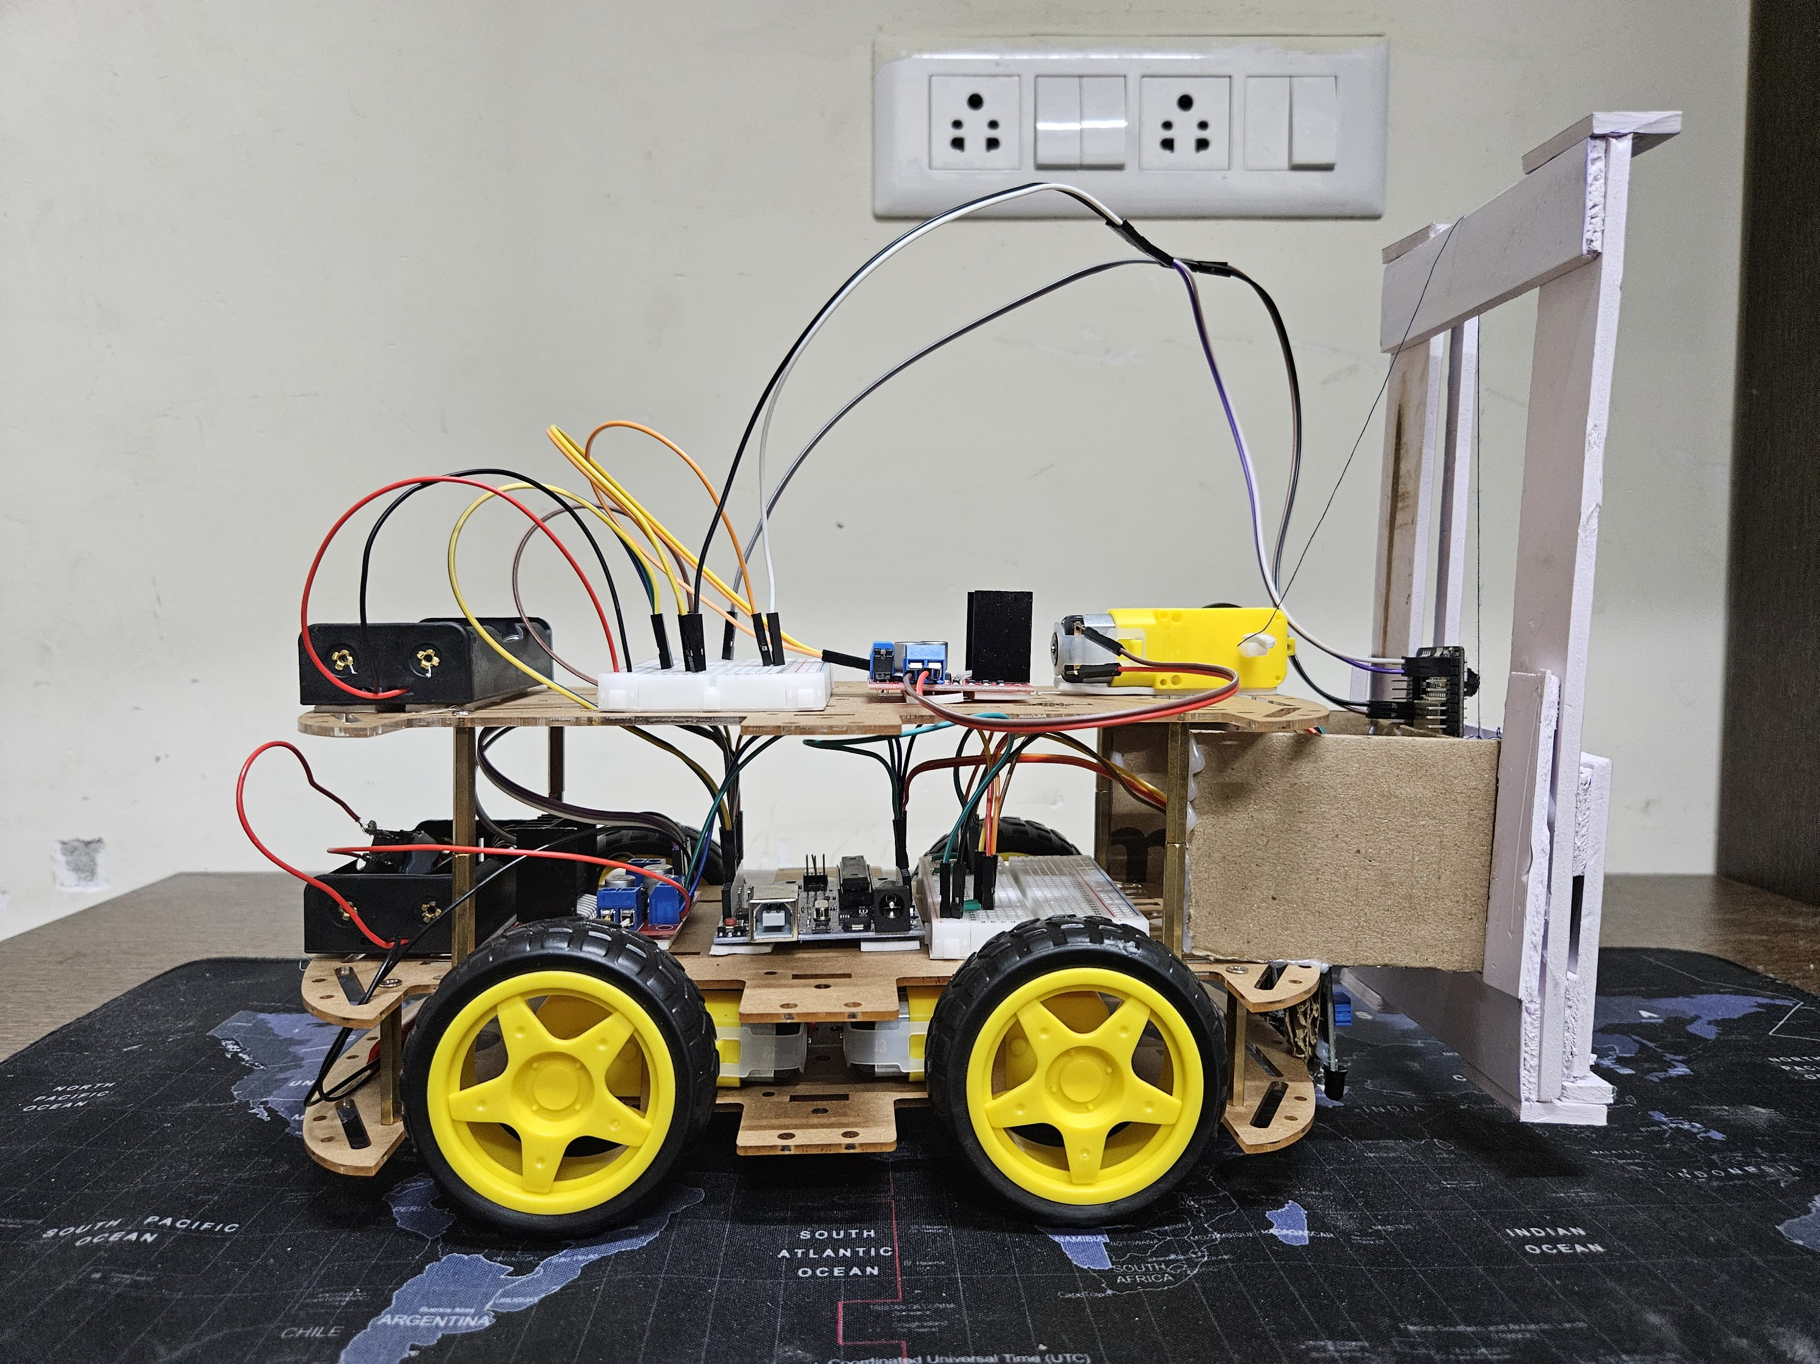

**Left Side View**

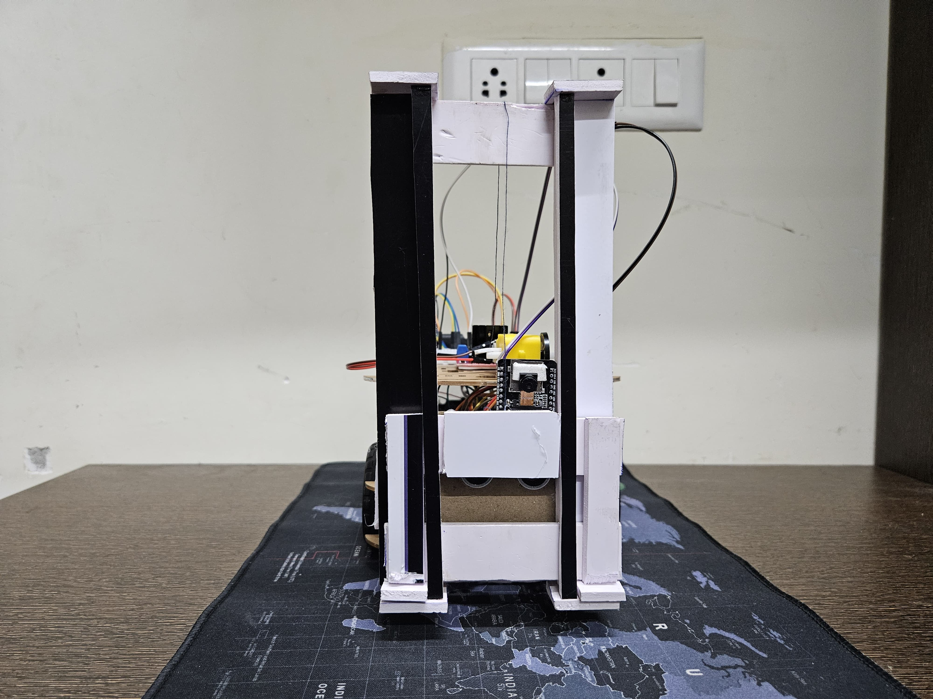

**Front View**

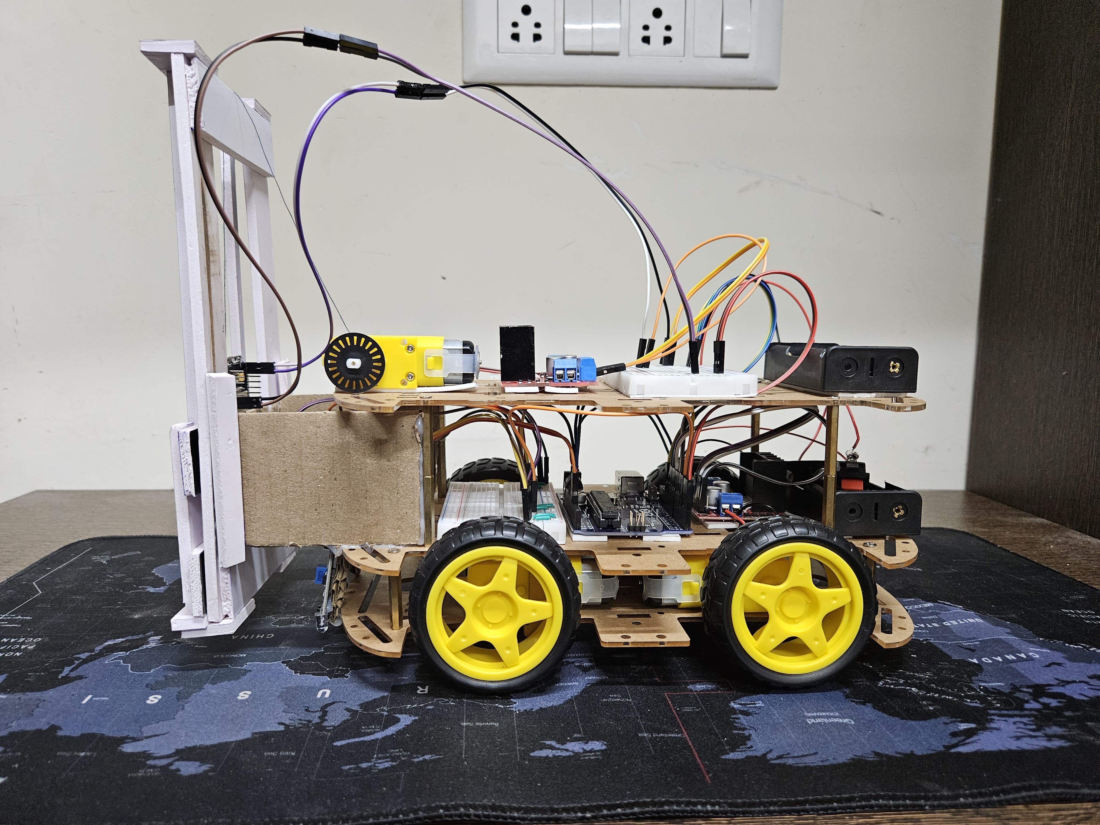

**Right Side View**

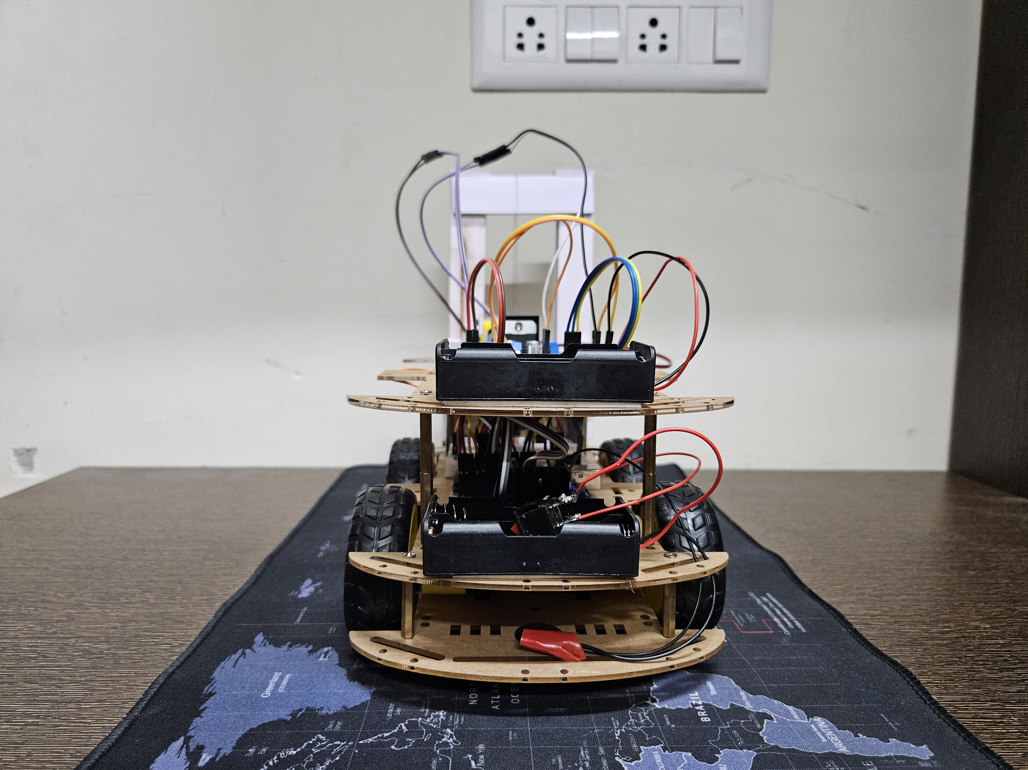

**Back View**

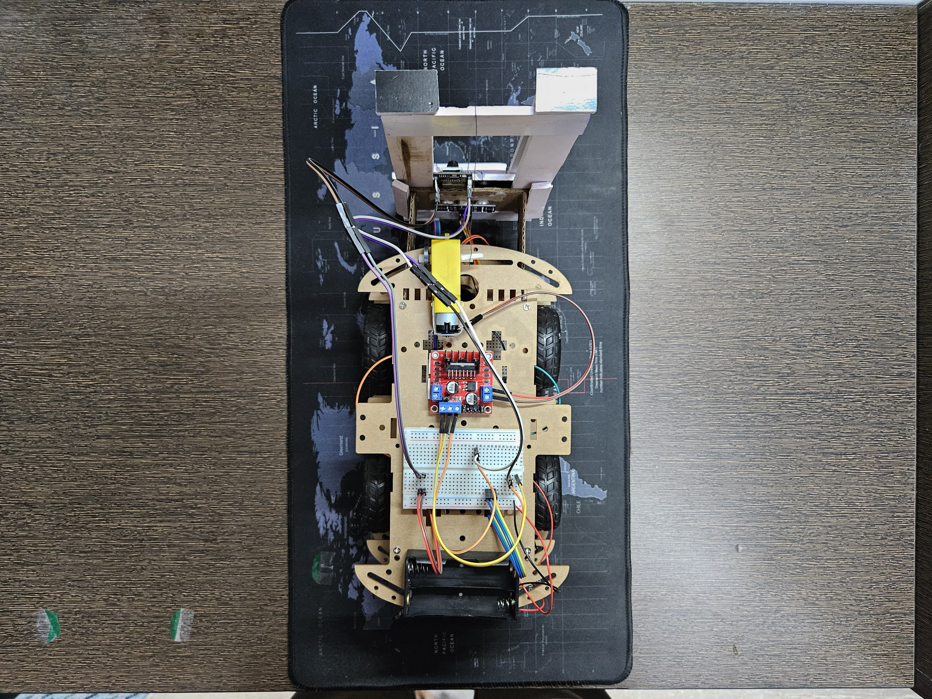

**Top View**

1. **INTRODUCTION**

**1.1 Problem statement**

Modern warehouses face significant challenges in managing the constant movement of goods. Common issues such as delays, incorrect item placements, and difficulties with inventory verification are often due to human error. As warehouse operations grow increasingly complex, there is a clear need for a more efficient solution to handle these tasks.

The proposed solution is to develop a robotic automation system capable of navigating the warehouse, picking up and delivering products to designated locations, and interacting directly with the inventory system. This robot will use ESP32-CAM scanning for item identification, image recognition to verify objects, and a secure wireless connection through the warehouse network for real-time data reporting. The implementation of such automation will reduce human error, improve operational efficiency, and enable more responsive control over product management.

**1.2 Aim & objective :**

The aim of WareOps is to develop an autonomous robot that can efficiently handle warehouse tasks, such as moving, sorting, and managing goods, while integrating with an inventory system for real-time updates and reducing human error. The objectives include automating warehouse operations by designing a robot capable of moving items to specified locations, using an ESP32-CAM module for object detection and sorting, and enabling real-time communication with the central inventory system. The robot will also incorporate IR and ultrasonic sensors for obstacle avoidance and navigation, along with a forklift mechanism for handling products of various sizes. Additionally, it will provide remote operation and monitoring capabilities, ensuring secure wireless communication, while continuous testing and optimization will enhance performance, precision, and efficiency.

1. **PROCEDURE :**
2. **Initial Setup and Powering Up**:
3. The WareOps robot is powered on using a battery source. The central control system, based on an **Arduino UNO**, manages all operations.
4. The **IR sensors** and **ultrasonic sensors** are initialized for navigation and obstacle detection, while the **ESP32-CAM** module is ready to handle image processing and communication tasks.
5. **Navigation and Obstacle Detection**:
6. The robot starts moving using **DC motors** controlled via **L298N motor drivers**. These motors allow the robot to move smoothly and precisely through the warehouse.
7. **IR sensors** track the floor for a predefined path, helping the robot follow a specific route (e.g., a black line) drawn on the floor.
8. **Ultrasonic sensors** continuously scan the environment, identifying obstacles in the robot’s path, and triggering the robot to change direction if necessary to avoid collisions.
9. **Object Detection and Sorting**:
10. As the robot moves, the **ESP32-CAM** scans the environment. The camera captures images of nearby items and processes them to identify their size and characteristics.
11. The robot uses a sorting algorithm, which employs **image processing** (like Yolo or other packages) to classify items into different sizes (small, medium, large).
12. Based on the size classification, the robot decides where to place the item in the warehouse. It sends this information to a **central server system** for real-time inventory updates and task management.
13. **Pick-and-Place Operation**:
14. When the robot arrives at the designated area with an item, the **forklift mechanism** mounted on the robot is activated. The forklift uses a **DC motor** to lift and transport the item.
15. The lifting mechanism is controlled precisely by the **Arduino UNO**, which operates the **L298N motor driver** to move the forklift up and down. The robot can lift blocks to various heights based on their size and weight.
16. **Inventory Management and Communication**:
17. The **ESP32-CAM** continuously captures images of the items being moved and updates the system with this data over a **Wi-Fi connection**.
18. The **central server system** receives the data from the camera module and processes it to maintain accurate and up-to-date inventory counts.
19. **Real-Time Reporting**:
20. As the robot continues to operate, it transmits data back to the warehouse system in real-time. This includes status updates on the robot’s location, the items it has picked, and the current stock levels.
21. The system provides real-time information on inventory, helping warehouse managers make decisions based on the latest data.
22. **System Optimization and Testing**:
23. The robot undergoes continuous testing to optimize its performance. Adjustments are made to ensure precise movement, accurate item identification, and efficient sorting.
24. The robot’s sensors and camera module are tuned for better navigation and object detection to handle different warehouse layouts and item types.
25. **Final Task Completion**:
26. Once the robot has completed its pick-and-place operations and sorted the items as required, it returns to its charging station or standby position.
27. The robot is ready for the next task, ensuring efficient and reliable warehouse management.

By combining autonomous navigation, real-time object detection, and efficient pick-and-place capabilities, the WareOps robot enhances warehouse operations, reduces human error, and improves inventory management

1. **RESULTS**

WareOps: a smart optimization warehouse using Arduino-powered robotics and drive-in racks.

WareOps is a solution that uses robotics to maximize warehouse efficiency by automating drive-in racks through Arduino-based operations. An Arduino UNO controls operations, while IR and ultrasonic sensors can be used to navigate and avoid obstacles in small storage areas. Real time identification and classification of objects are carried out in the ESP32-CAM module used by the robot. With the automation of updating inventory and managing tasks through Wi-Fi connectivity, WareOps not only reduces the storage requirement but also increases the accuracy of both inventory and operations in a warehouse.

1. **CONCLUSION**

In conclusion, with WareOps, a firm can significantly reduce the labor intensity of its warehouse operation processes while increasing productivity through advanced key technologies like autonomous navigation, real-time object detection, and efficient pick-and-place mechanisms. Precise navigation enabled by both IR and ultrasonic sensors, accurate item sorting through image processing algorithms, and real time updates through Wi-Fi communication make this system address crucial elements of warehouse management.

This implies that, on one hand, central control is carried through by using Arduino to control the system, and on the other hand, real-time data is relayed to the warehouse system for inventory visibility so that data-driven decision-making is available to the managers in charge of the warehouse and enhancing the accuracy of stock management. Testing and optimization are incessant to allow the robot flexibility and adaptability to varied warehouse layouts and item types - a scalable solution growing with operational demand. Finally, by streamlining inventory processes, minimizing human error, and adding their value to a highly efficient and reliable warehouse management system, the WareOps robot produces ultimate warehouse benefits.

**5.Prior Art:**

|  |  |  |  |
| --- | --- | --- | --- |
| **S.NO** | **PRIOR ART** | **AUTHORS** | **LIMITATIONS** |
| **1.** | **1)An RFID Warehouse Robot**  **(https://ieeexplore.ieee.org/document/4658428/authors#authors)** | **Loh Poh Chuan, Ayob Johari, Mohd Helmy Abd Wahab, Danial Md. Nor, Nik Shahidah Afifi Md. Taujuddin, and Mohd Erdi Ayob** | **Lack of obstacle detection.** |
| **2.** | **2) Implementation of Pick & Place Robotic Arm for Warehouse Products Management (https://ieeexplore.ieee.org/abstract/document/9526304)** | **Nazib Sobhan and Abu Salman Shaikat** | **Absence of box sorting based on size.** |
| **3.** | **Microcontroller-based Forklift Path Following Robot Prototype**  **(http://www.pubs.ascee.org/index.php/iota/article/view/733)** | **Shandy Tresnawati , Nia Ekawati and Maulana Fadjar Siddiq** | **Image processing not available.** |
| **4.** | **4)Visual Marker-Guided Mobile Robot Solution for Automated Item Picking in A Warehouse**  **(https://ieeexplore.ieee.org/abstract/document/8014018)** | **Albert Causo , Zheng-Hao Chong ,Ramamoorthy Luxman and I-Ming Chen** | **Inefficient lifting due to the absence of a forklift** |
| **5.** | **5) Mobile Dual-Arm Robot for Automated Order Picking System in Warehouse Containing Various Kinds of Products**  **(https://ieeexplore.ieee.org/document/7404942)** | **Nobutaka Kimura ,Kiyoto Ito, Taiki Fuji ,Keisuke Fujimoto ,Kanako Esaki , Fumiko Beniyama and Toshio Moriya** | **Deficiency in line-following capability for effective robot mobility** |

**6.LIST OF CODES:**

6.1 Code implementation for Arduino UNO:

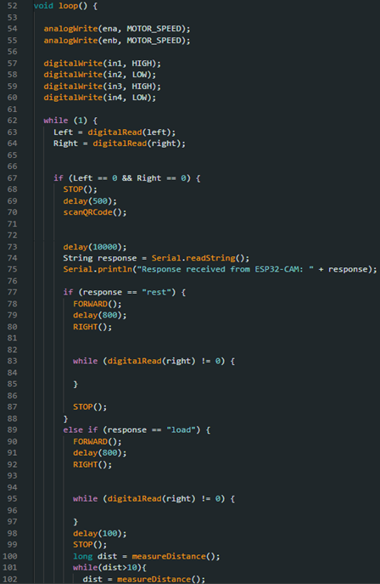

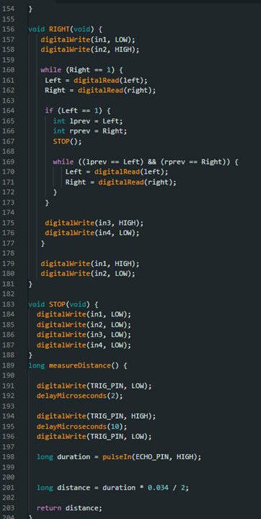

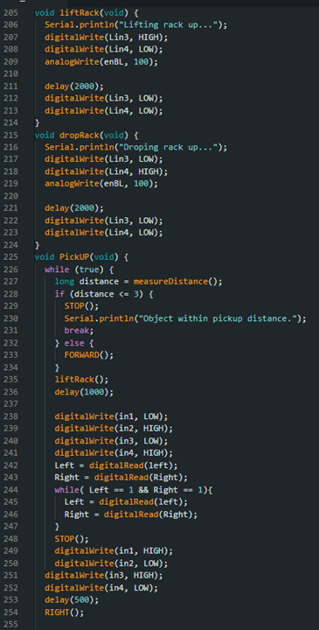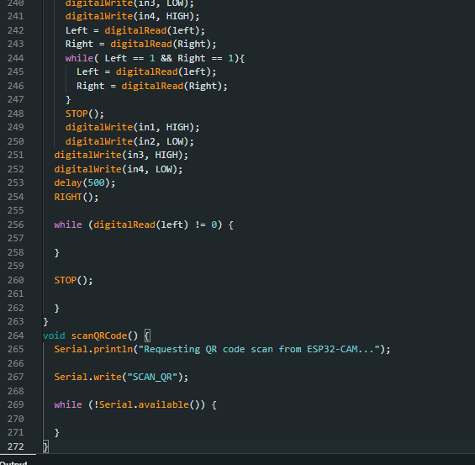

6.2 Code implementation for ESP32 CAM:



